CPT-202 ASSIGNMENT – 8 SQL
- USE KimTay Pet Supplies DATABASE
- Each question is worth 10 points.
- Answer each of the following questions after reading/reviewing Chapter 8 of your textbook.
- For questions that require SQL Code, submit both your SQL Code and the Output/Results.
- Submit your answers in a Word document via the Assignments link in D2L.

- Submit the SQL Code (and the output/results) that will do the following: List the item ID and description for all items. The descriptions should appear in uppercase letters. SORT the output by Item_ID.

select ITEM_ID, upper(description) as DESCRIPTION
from ITEM
order by ITEM_ID

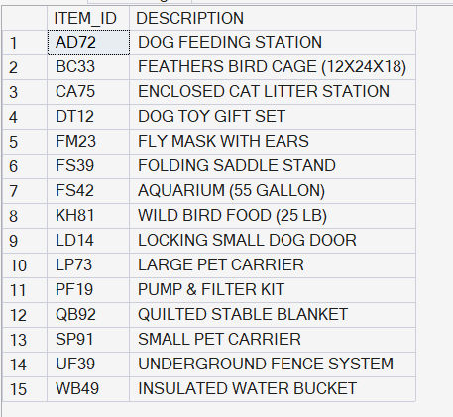

- Submit the SQL Code (and the output/results) that will do the following: List the customer ID and first and last names for all customers located in the city of Cody. Your query should ignore case. For example, a customer with the city Cody should be included, as should customers whose city is CODY, cody, cOdY, and so on. SORT the output by Cust_ID.

select CUST_ID, FIRST_NAME, LAST_NAME
from CUSTOMER
where lower(city) = 'cody'
order by CUST_ID

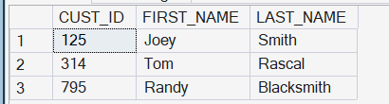

- Submit the SQL Code (and the output/results) that will do the following: List the customer ID, first and last names, and balance for all customers. The balance should be rounded to the nearest dollar. SORT the output by Cust_ID.

select CUST_ID, FIRST_NAME, LAST_NAME, round(BALANCE, 0) as balance
from CUSTOMER
order by CUST_ID

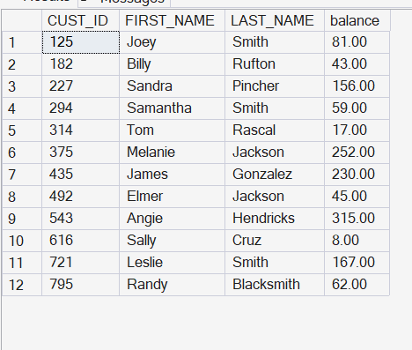

- KimTay Pet Supplies is running a promotion that is valid for up to 20 days after an order is placed. Submit the SQL Code (and the output/results) that will do the following: List the invoice number, customer ID, customer first and last names, and the promotion date for each invoice. The promotion date is 20 days after the invoice was placed. SORT the output by Invoice Number.

select i.INVOICE_NUM, c.CUST_ID, c.FIRST_NAME, c.LAST_NAME, DATEADD(day, 20, i.INVOICE_DATE) as promo_date
from invoices i, CUSTOMER c
where i.CUST_ID = c.CUST_ID
order by i.INVOICE_NUM

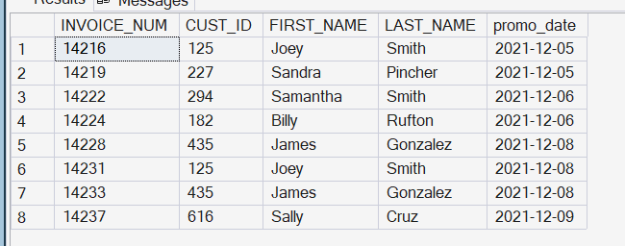

- Submit the SQL Code (and the output/results) that will do the following: Create a SQL Server Stored Procedure (name it usp_GetInvoiceDetail_<YourStudentID>) that will accept an Invoice Number as a single input parameter then display the invoice date, customer ID, and customer’s first and last names for that specific invoice number. The customer’s first and last names should be displayed as a single column, labeled “Full Name”, with the last name in all caps followed by a comma, a space, and the first name like this:
Full Name
SMITH, Joey
Now, execute your Stored Procedure for invoice number 14216, and display the output/results.

create procedure usp_getinvoicedetail_042854
@invoice_num int
as
begin
select invoice_date,
cust_id,
upper(cust_last_name) + ', ' + cust_first_name as [full name]
from invoices, customer
where invoices.cust_id = customer.cust_id
and invoices.invoice_num = @invoice_num;
end;

- Submit and execute the SQL Code (and the output/results) that will do the following: Create a SQL Server Stored Procedure (SP) that changes the price of an item with a given item ID from the ITEM table. Your SP will take two (2) input parameters, one for the Item ID and one for the price. Name your SP usp_ChangePrice_<YourStudentID>.

create procedure usp_changeprice_042854
@item_id char(4),
@new_price decimal(7,2)
as
begin
update item
set price = @new_price
where item_id = @item_id;
end;

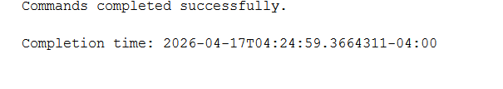

- Submit the SQL Code (and the output/results) that will do the following: Create a SQL Server Stored Procedure (SP) to display the Sales Rep assigned to Customers that have a balance exceeding a given amount. That given amount should be the single input parameter of your SP. Name your SP usp_DisplaySalesRep_<YourStudentID>. NOTE: Your SP MUST use a cursor (Hint: see section 8-9d in textbook). Use the cursor to generate and print the list of customers (first and last names only) whose balance exceeds the specified amount, and the Sales Rep name (sales rep’s first and last name only) for each customer in the list, like this:
The Sales Rep for Customer Joey Smith is: Susan Garcia
The Sales Rep for Customer Billy Rufton is: Richard Miller
The Sales Rep for Customer Sandra Pincher is: Donna Smith
Now, execute your Stored Procedure for customers whose balance exceeds $100, and display the output/results.

create procedure usp_displaysalesrep_042854
@balance decimal(7,2)
as
begin
declare @cf varchar(25)
declare @cl varchar(25)
declare @rf varchar(25)
declare @rl varchar(25)

declare sales_cursor cursor for
select c.first_name, c.last_name,
r.first_name, r.last_name
from customer c, sales_rep r
where c.rep_id = r.rep_id
and c.balance > @balance

open sales_cursor

fetch next from sales_cursor
into @cf, @cl, @rf, @rl

while @@fetch_status = 0
begin
print 'the sales rep for customer ' + @cf + ' ' + @cl +
' is: ' + @rf + ' ' + @rl

fetch next from sales_cursor
into @cf, @cl, @rf, @rl
end

close sales_cursor
deallocate sales_cursor
end;

exec usp_displaysalesrep_042854 100;

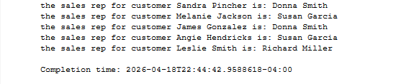

- Submit and execute the SQL Code that will do the following: Create a table named PriceAuditLog_<YourStudentID>. Here’s the table details:
COLUMN NAME | DATA TYPE
Item_ID | Char(4)
Old_Price | Decimal(7,2)
New_Price | Decimal(7,2)
Change_Date (Primary Key) | DateTime
create table priceauditlog_042854
(
item_id char(4),
old_price decimal(7,2),
new_price decimal(7,2),
change_date datetime primary key
);

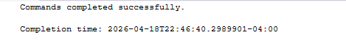

- Submit and execute the SQL Code that will do the following: Create a SQL Server Trigger on the existing ITEM table in the KimTay database. Name your Trigger UpdateItem_<YourStudentID>. Here’s how the Trigger should work: whenever you UPDATE (i.e., change) the Price of an Item, record the Item_ID, Old Price, New Price, and the current system date/time in your PriceAuditLog_<YourStudentID> table (Hint: see section 8-10 in your textbook).

create trigger updateitem_042854
on item
after update
as
begin
insert into priceauditlog_042854
(item_id, old_price, new_price, change_date)

select d.item_id, d.price, i.price, getdate()
from deleted d, inserted i
where d.item_id = i.item_id
and d.price <> i.price;
end;
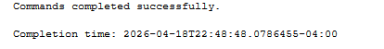
- Submit the SQL Code (and the output/results) that will do the following:
- Execute the Stored Procedure you created in Question 6 above (usp_ChangePrice_<YourStudentID>) that will change the Price of Item_ID BC33 to $71.50.
exec usp_changeprice_042854 'bc33', 71.50;
- Display all details for Item_ID BC33 to show the new Price of $71.50.
select *
from item
where item_id = 'bc33';

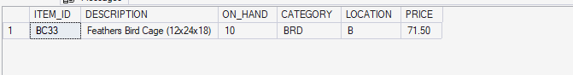
- Execute your Stored Procedure again that will change the Price of Item_ID BC33 back to $79.99.
exec usp_changeprice_042854 'bc33', 79.99;
- Display all details for Item_ID BC33 again to show the Price has been changed back to $79.99.
select *
from item
where item_id = 'bc33';
- Display all details from your PriceAuditLog_<YourStudentID> table that you created in Question 8. These details should show the data that was entered into your table using your UpdateItem_<YourStudentID> Trigger.

select *
- from priceauditlog_042854;
